Lab Task 12

Q No1:

def div(x,y):
try:
return float(x)/y
except ZeroDivisionError:
print "The number cannot be divided by Zero"

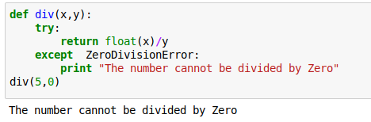

Q No 2:

def fun():
try:
person = {}
properties = [
("name", str),
("surname", str),
("age", int),
("height", float),
("weight", float),]
for prop, p_type in properties:
person[prop] = p_type(raw_input("Please enter your %s: " % prop))
except NameError:
print ("The name is not find in records")
fun()
except TypeError:
print ("please enter a integer value")
fun()
except ValueError:
print ("Please enter a integer value")
fun()
Q No 3:

def print_list_element(thelist, index):
try:
print(thelist[index])
return
except IndexError:
print ("The index in exceeding from the length of list")

Q No 4:

def fun():
try:
person = {}
properties = [
("name", str),
("surname", str),
("age", int),
("height", float),
("weight", float),]
for prop, p_type in properties:
person[prop] = p_type(raw_input("Please enter your %s: " % prop))
except NameError as f:
print f
fun()
except TypeError as k:
print k
fun()
except KeyError as n:
print n
fun()
except ValueError as m:
print m
fun()

